Week: 05-01
ROLL NO.: 241801310
Name: Vidhyashree.J
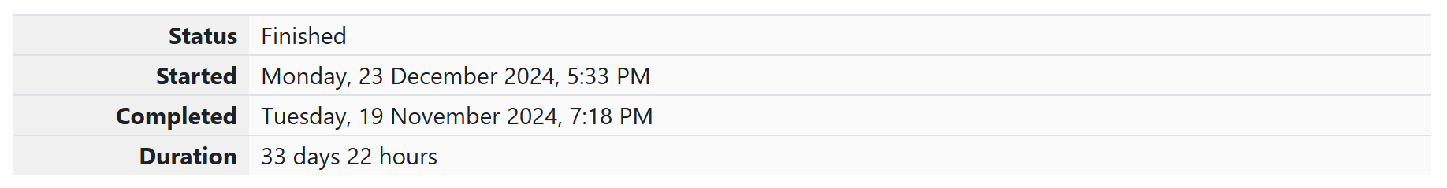
Q1) Write a program that prints a simple chessboard.
Input format:
The first line contains the number of inputs T.
The lines after that contain a different value for size of the chessboard
Output format:
Print a chessboard of dimensions size * size.
Print W for white spaces and B for black spaces.
Sample Input:
2
3
5
Sample Output:
WBW
BWB
WBW
WBWBW
BWBWB
WBWBW
BWBWB
WBWBW

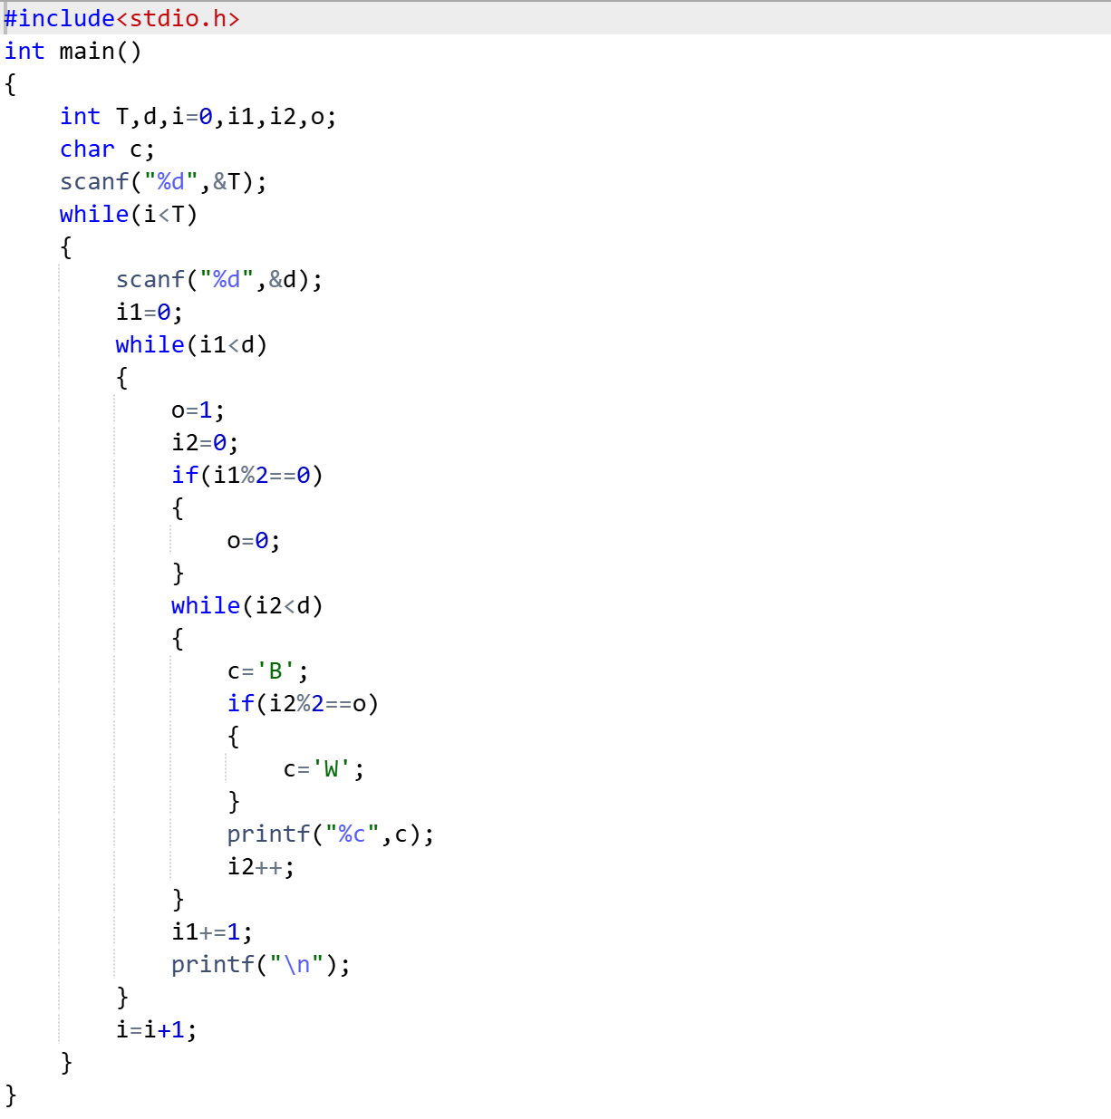
OUTPUT:
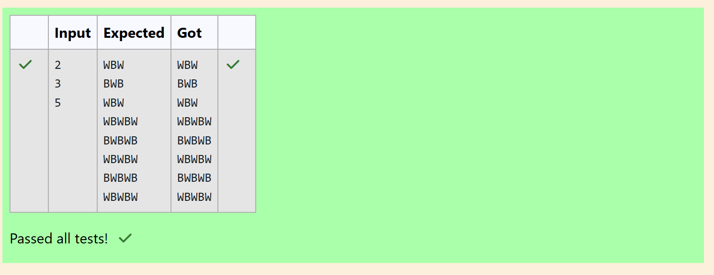

Q2) Let’s print a chessboard!
Write a program that takes input:
The first line contains T, the number of test cases
Each test case contains an integer N and also the starting character of the chessboard
Output Format
Print the chessboard as per the given examples
Sample Input:
2
2 W
3 B
Sample Output:
WB
BW
BWB
WBW
BWB
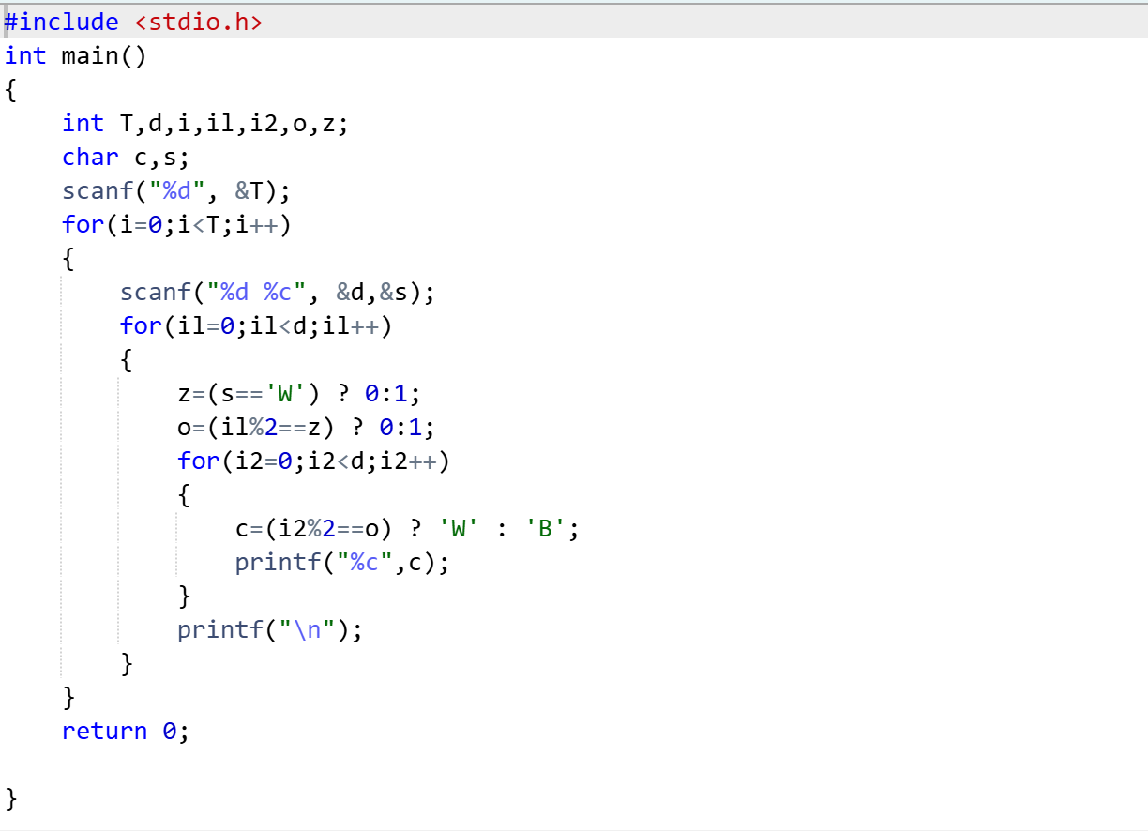
OUTPUT:
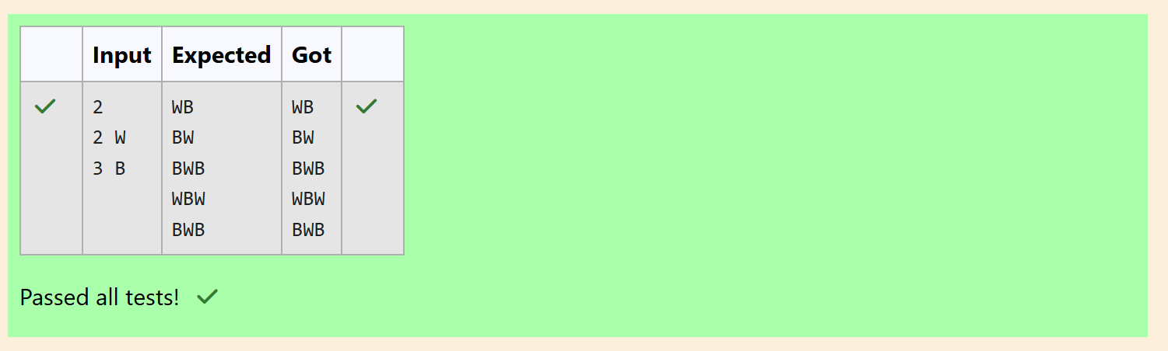

Q3) Decode the logic and print the Pattern that corresponds to given input.
If N= 3 then pattern will be:
10203010011012
**4050809
****607
If N= 4, then pattern will be:
1020304017018019020
**50607014015016
****809012013
******10011
Constraints: 2 <= N <= 100
Input Format
First line contains T, the number of test cases, each test case contains a single integer N
Output Format
First line print Case #i where i is the test case number, In the subsequent line, print the
pattern
Sample Input
3
3
4
5
Sample Output
Case #1
10203010011012
**4050809
****607
Case #2
1020304017018019020
**50607014015016
****809012013
******10011
Case #3
102030405026027028029030
**6070809022023024025
****10011012019020021
******13014017018
********15016
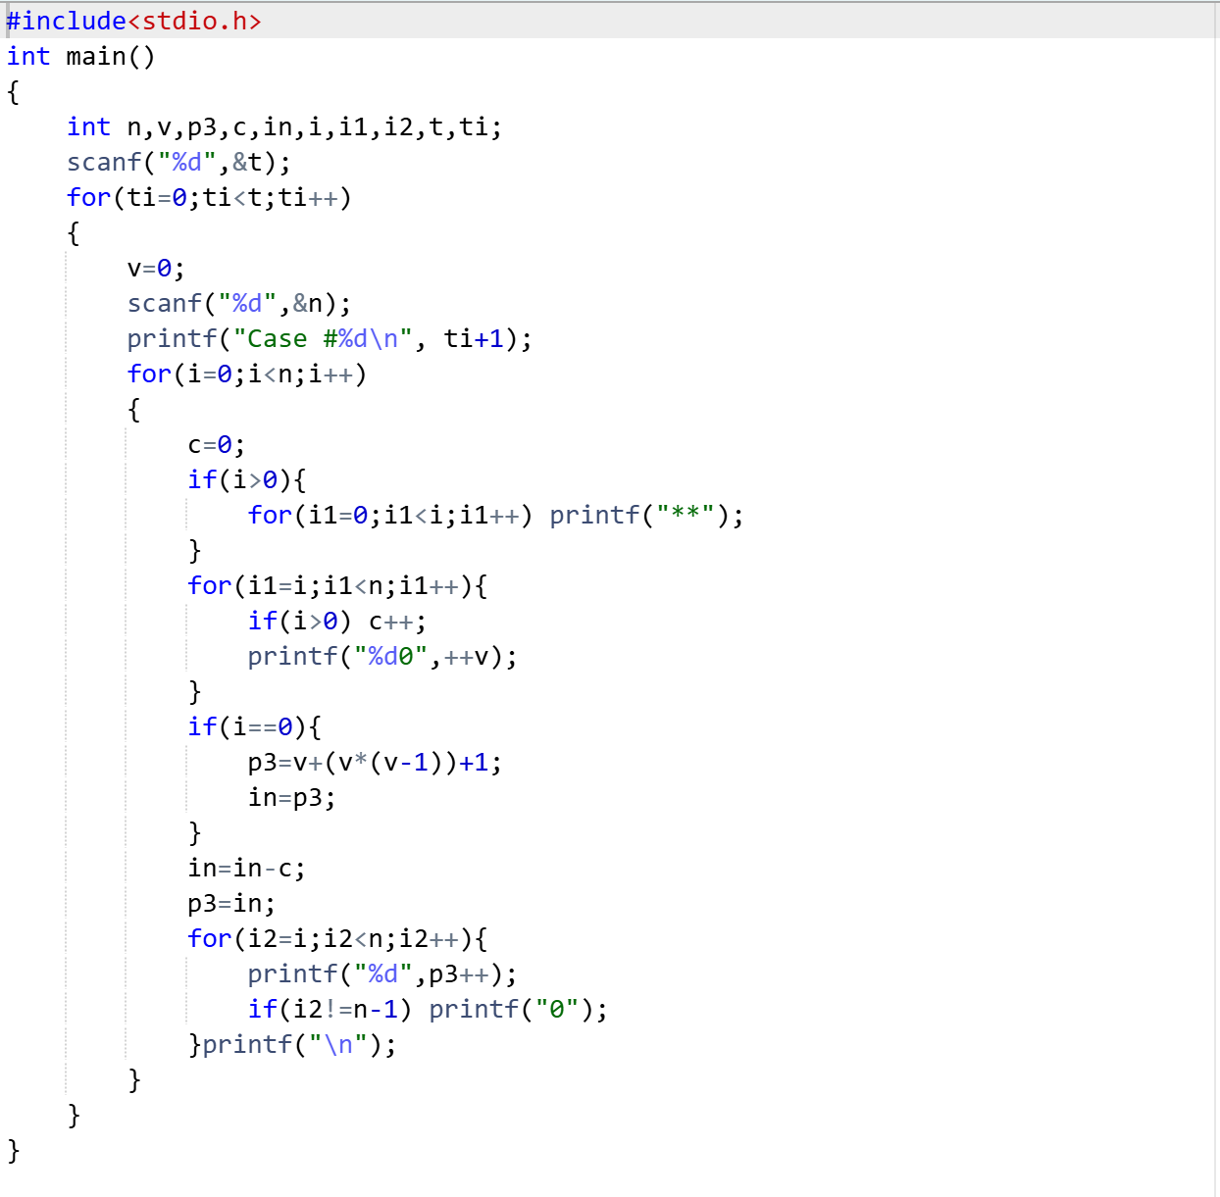

OUTPUT:
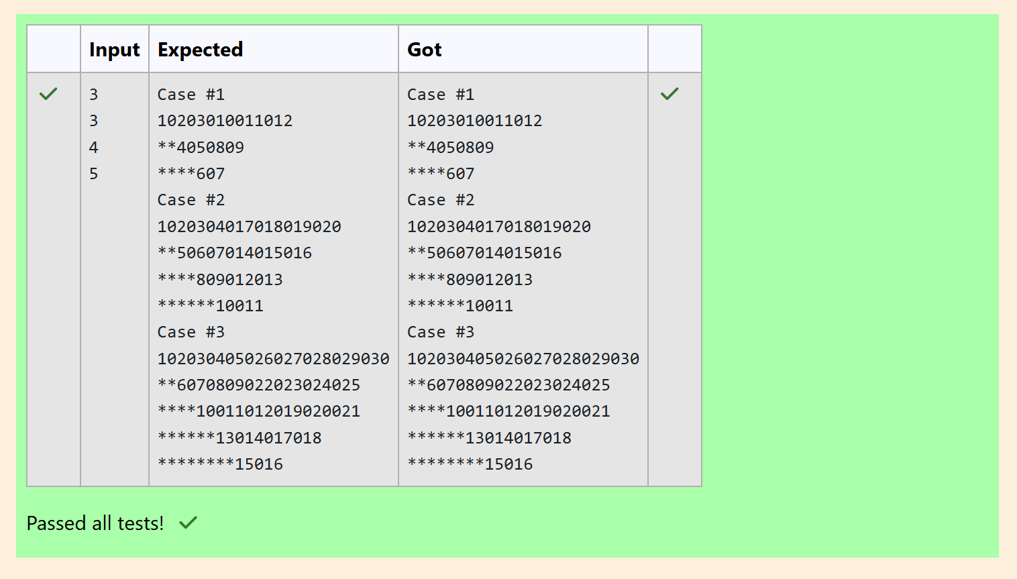
Week:05-02
ROLL NO.:241801310
Name: Vidhyashree.J
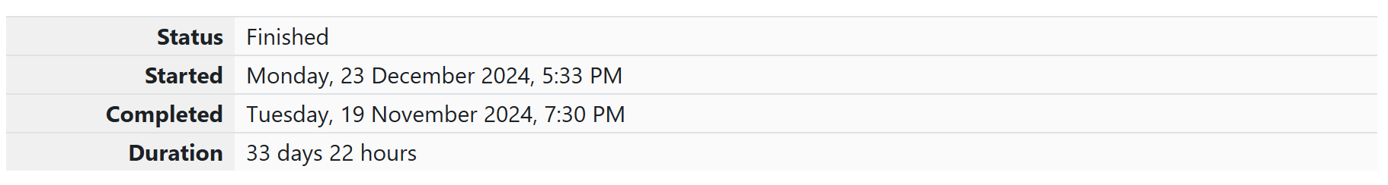
Q1)
The k-digit number N is an Armstrong number if and only if the k-th power of each digit
sums to N.
Given a positive integer N, return true if and only if it is an Armstrong number.
Note: 1 <= N <= 10^8
Hint: 153 is a 3-digit number, and 153 = 1^3 + 5^3 + 3^3.
Sample Input:
153
Sample Output:
true
Sample Input:
123
Sample Output:
false
Sample Input:
1634
Sample Output:
true
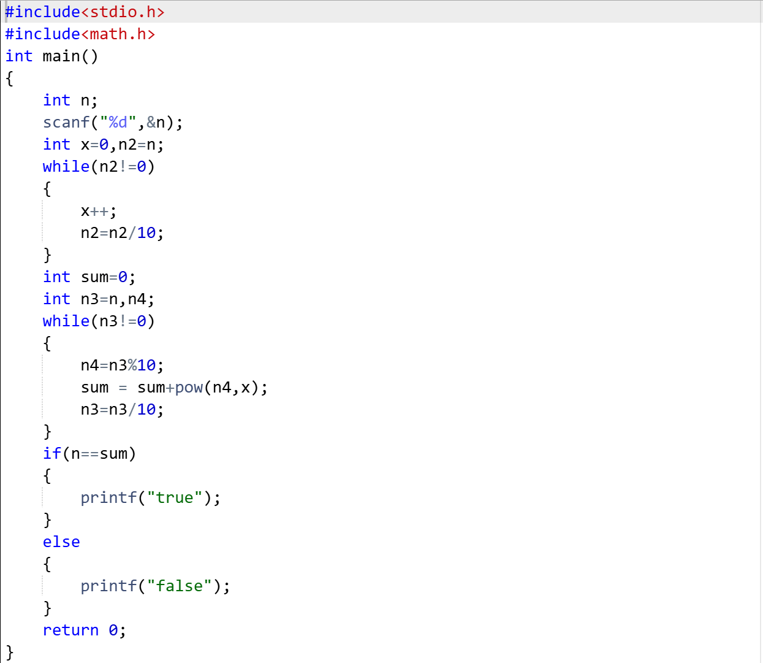
OUTPUT: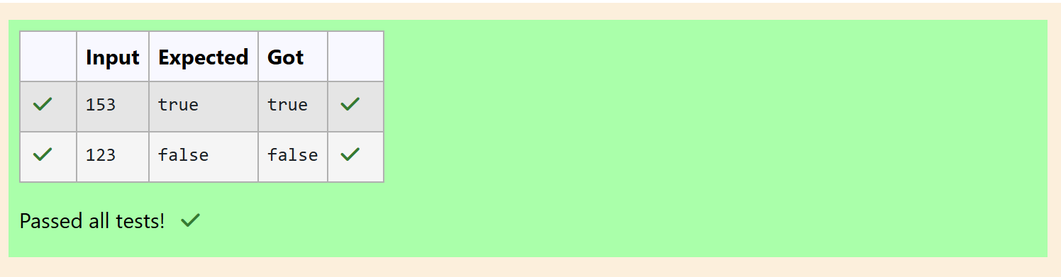

Q2) Take a number, reverse it and add it to the original number until the obtained number is
a palindrome.
Constraints
1<=num<=99999999
Sample Input 1
32
Sample Output 1
55
Sample Input 2
789
Sample Output 2
6606
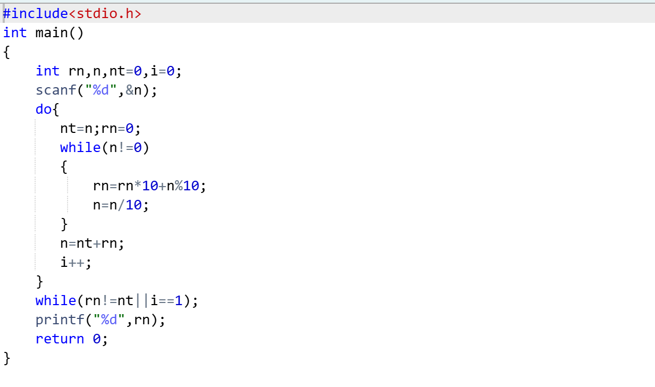
OUTPUT:
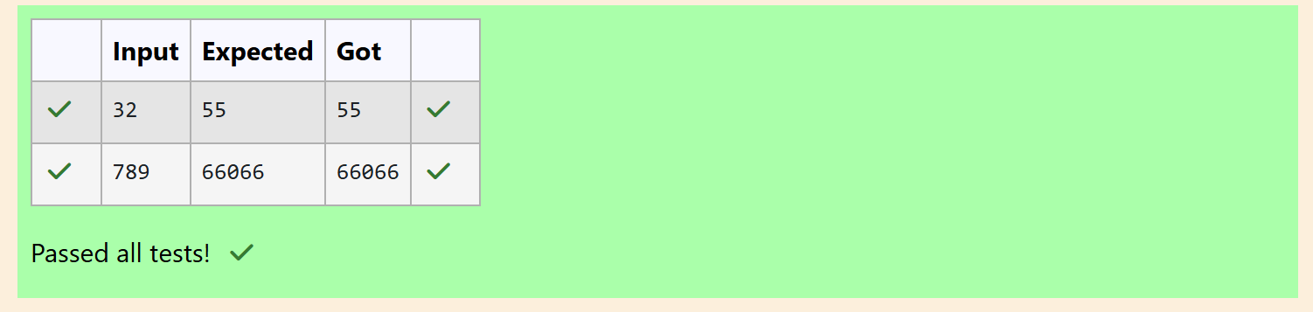

Q3) A number is considered lucky if it contains either 3 or 4 or 3 and 4 both in it. Write a
program to print the nth lucky number. Example, 1st lucky number is 3, and 2nd lucky
number is 4 and 3rd lucky number is 33 and 4th lucky number is 34 and so on. Note that
13, 40 etc., are not lucky as they have other numbers in it.
The program should accept a number 'n' as input and display the nth lucky number as
output.
Sample Input 1:
3
Sample Output 1:
33
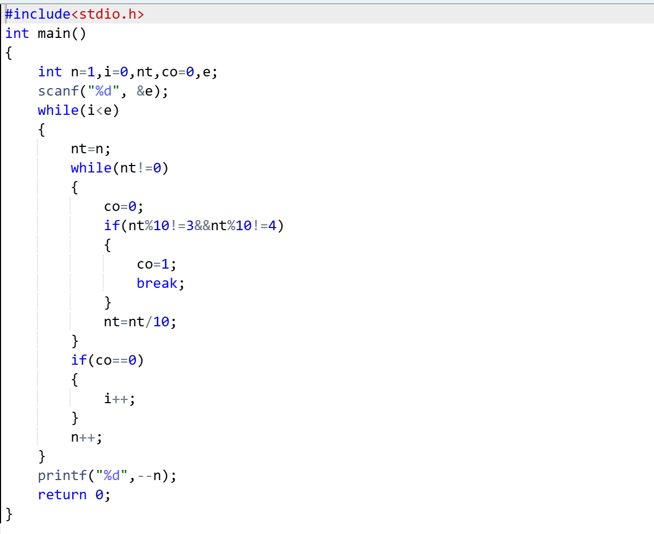
OUTPUT:
